Cognizant - DN 4.0 Deep Skilling Java FSE

Week 02 – TDD using Junit5 and Mockito

Superset ID: 6383725

Name: G Ashritha

**Exercise 1: Setting Up JUnit**

//CalculatorTest

package testcases;

import org.junit.Test;

import static org.junit.Assert.*;

public class CalculatorTest {

*@Test*

public void testAddition() {

*assertEquals*(5, 2 + 3);

}

}

**Output:**

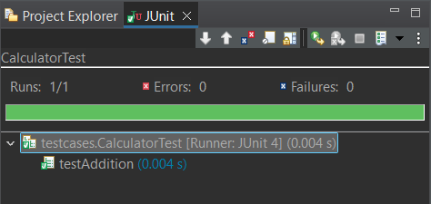

**Exercise 2: Assertions in JUnit**

//AssertionTest.java

package testcases;

import static org.junit.Assert.*;

import org.junit.Test;

public class AssertionsTest {

*@Test*

public void testAssertions() {

*assertEquals*(5, 2 + 3);

*assertTrue*(5 > 3);

*assertFalse*(5 < 3);

*assertNull*(null);

*assertNotNull*(new Object());

}

}

**Output:**

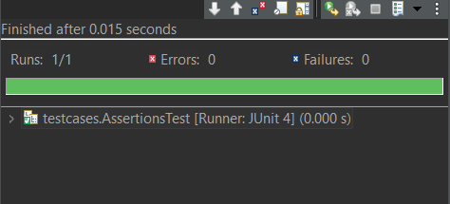

**Exercise 3: Arrange-Act-Assert (AAA) Pattern, Test Fixtures, Setup and Teardown Methods in JUnit**

**//**Calculator.java

package testcases;

public class Calculator {

public int add(int a, int b) {

return a + b;

}

public int subtract(int a, int b) {

return a - b;

}

}

//CalculatorTest.java

package testcases;

import static org.junit.Assert.*;

import org.junit.Before;

import org.junit.After;

import org.junit.Test;

public class CalculatorTest {

private Calculator calculator;

*@Before*

public void setUp() {

calculator = new Calculator();

System.***out***.println("Setup complete");

}

*@After*

public void tearDown() {

calculator = null;

System.***out***.println("Teardown complete");

}

*@Test*

public void testAddition() {

// Arrange

int a = 5;

int b = 3;

// Act

int result = calculator.add(a, b);

// Assert

*assertEquals*(8, result);

}

*@Test*

public void testSubtraction() {

// Arrange

int a = 10;

int b = 4;

// Act

int result = calculator.subtract(a, b);

// Assert

*assertEquals*(6, result);

}

}

**Output:**

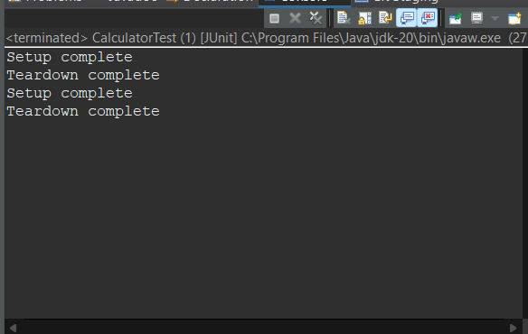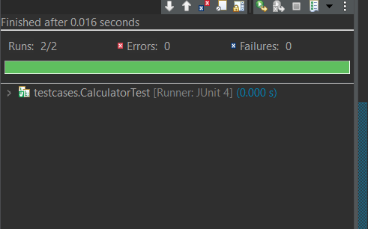

**Exercise 4: Mocking and Stubbing**

//pom.xml

<dependencies>

<!-- JUnit 4 -->

<dependency>

<groupId>junit</groupId>

<artifactId>junit</artifactId>

<version>4.13.2</version>

<scope>test</scope>

</dependency>

<!-- Mockito -->

<dependency>

<groupId>org.mockito</groupId>

<artifactId>mockito-core</artifactId>

<version>4.11.0</version>

<scope>test</scope>

</dependency>

</dependencies>

//ExternalApi.java

package com.example;

public interface ExternalApi {

String getData();

}

//MyService.java

package com.example;

public class MyService {

private ExternalApi api;

public MyService(ExternalApi api) {

this.api = api;

}

public String fetchData() {

return api.getData();

}

}

//MyServiceTest.java

package com.example;

import org.junit.Test;

import static org.junit.Assert.*;

import static org.mockito.Mockito.*;

import org.mockito.Mockito;

public class MyServiceTest {

@Test

public void testExternalApi() {

// Arrange

ExternalApi mockApi = Mockito.mock(ExternalApi.class);

when(mockApi.getData()).thenReturn("Mock Data");

MyService service = new MyService(mockApi);

// Act

String result = service.fetchData();

// Assert

assertEquals("Mock Data", result);

}

}

**Output:**

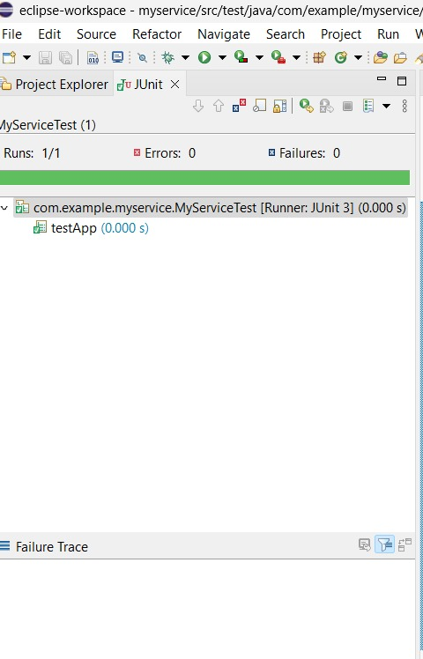

**Exercise 5: Verifying Interactions**

//MyService.java

package com.example;

public class MyService {

private ExternalApi api;

public MyService(ExternalApi api) {

this.api = api;

}

public String fetchData() {

return api.getData();

}

}

**//**MyServiceTest.java

package com.example;

import org.junit.Test;

import static org.mockito.Mockito.*;

import org.mockito.Mockito;

public class MyServiceTest {

@Test

public void testVerifyInteraction() {

// Arrange

ExternalApi mockApi = Mockito.mock(ExternalApi.class);

MyService service = new MyService(mockApi);

// Act

service.fetchData();

// Assert

verify(mockApi).getData();

}}

**Output:**



**Exercise 6: Logging Error Messages and Warning Levels**

//pom.xml

<project xmlns="http://maven.apache.org/POM/4.0.0" xmlns:xsi="http://www.w3.org/2001/XMLSchema-instance" xsi:schemaLocation="http://maven.apache.org/POM/4.0.0 https://maven.apache.org/xsd/maven-4.0.0.xsd">

<modelVersion>4.0.0</modelVersion>

<groupId>com.example</groupId>

<artifactId>LoggingDemo</artifactId>

<version>0.0.1-SNAPSHOT</version>

<dependencies>

<dependency>

<groupId>org.slf4j</groupId>

<artifactId>slf4j-api</artifactId>

<version>1.7.30</version>

</dependency>

<dependency>

<groupId>ch.qos.logback</groupId>

<artifactId>logback-classic</artifactId>

<version>1.2.3</version>

</dependency>

</dependencies>

</project>

//LoggingExample.java

package com.example;

import org.slf4j.Logger;

import org.slf4j.LoggerFactory;

public class LoggingExample {

private static final Logger logger = LoggerFactory.getLogger(LoggingExample.class);

public static void main(String[] args) {

logger.error("This is an error message");

logger.warn("This is a warning message");

}

}

**Output:**

